Project Design Phase-II
Data Flow Diagram & User Stories

Date | 30 September 2026
Team ID | SWTID-2026-8886
Project Name | Implement Client Script and UI Policy for Incident
Maximum Marks | 4 Marks

Data Flow Diagrams:
A Data Flow Diagram (DFD) is a traditional visual representation of the information flows within a system. A neat and clear DFD can depict the right amount of the system requirement graphically. It shows how data enters and leaves the system, what changes the information, and where data is stored.
Example: DFD Level 0 (Industry Standard)
Example: (Simplified)
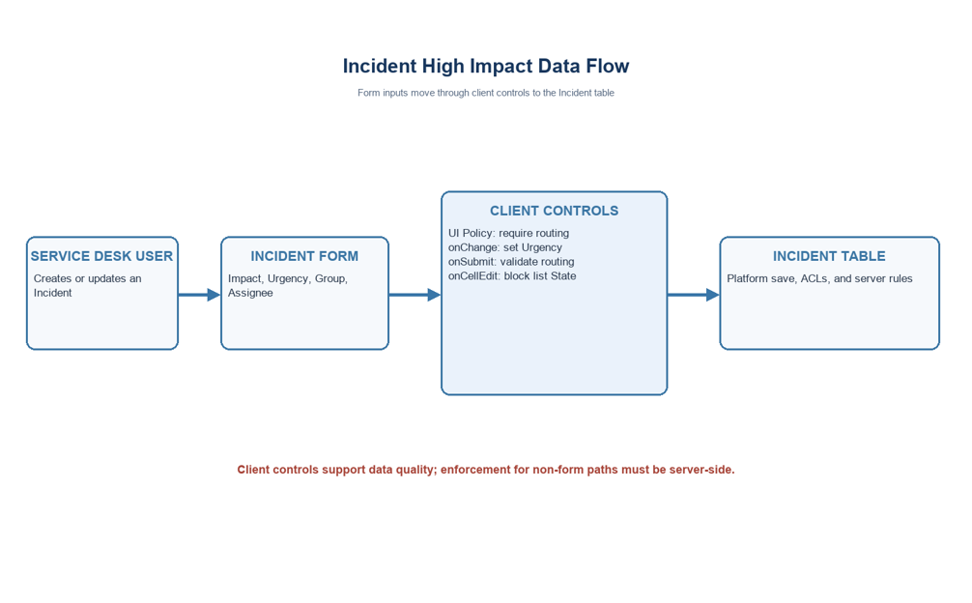
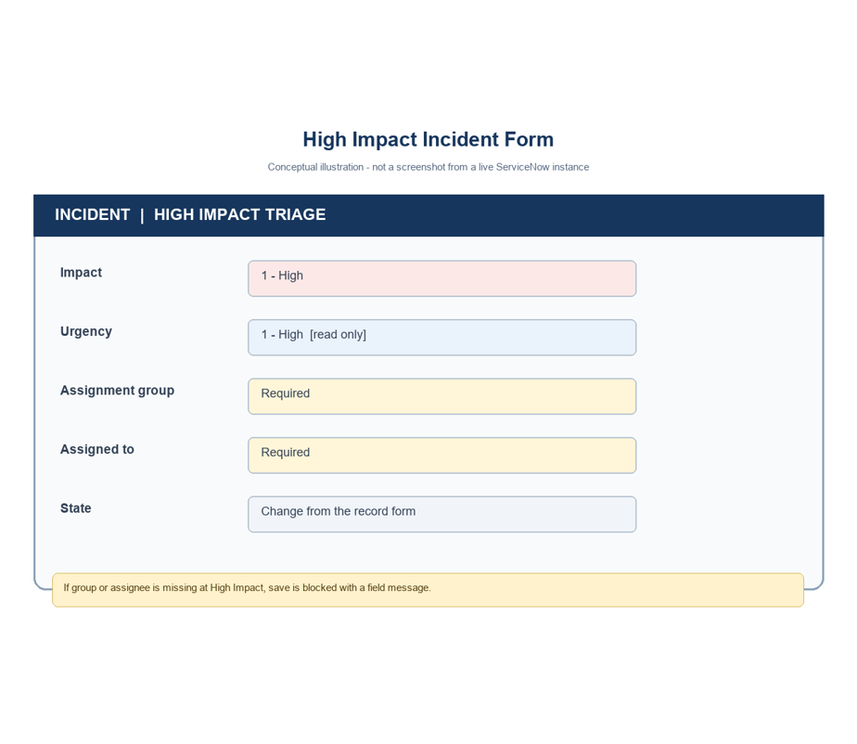

User Stories
Use the below template to list all the user stories for the product.
User Type | Functional Requirement (Epic) | User Story Number | User Story / Task | Acceptance criteria | Priority | Release
Service desk agent | High impact | USN-1 | As an agent, require Assignment group and Assigned to when Impact is High. | Both fields mandatory at Impact=1. | High | Sprint-1
Service desk agent | Urgency | USN-2 | As an agent, set Urgency High when I set Impact High. | Urgency changes to value 1 once. | High | Sprint-1
Service desk agent | Save validation | USN-3 | As an agent, explain missing routing before saving. | Save blocked with message on missing group. | High | Sprint-1
Service desk agent | Save validation | USN-4 | As an agent, explain missing assignee before saving. | Save blocked with message on missing assignee. | High | Sprint-1
Incident manager | Policy reversal | USN-5 | As a manager, reverse the controls when Impact is reduced. | Mandatory/read-only effects reverse. | High | Sprint-1
Service desk lead | List workflow | USN-6 | As a lead, prevent State list edits in the demo. | List edit rejected with guidance. | Medium | Sprint-2
Service desk agent | Form workflow | USN-7 | As an agent, update State from the record form. | Form update follows platform rules. | Medium | Sprint-2
Project tester | UAT | USN-8 | As a tester, run a repeatable set of checks. | 8 scenarios recorded with outcomes. | High | Sprint-2
Platform admin | Compatibility | USN-9 | As an admin, confirm fields and values before activation. | Field and choice checks documented. | High | Sprint-1
Platform admin | Security | USN-10 | As an admin, keep server-side enforcement authoritative. | Limitations and extension documented. | High | Sprint-2
Project reviewer | Documentation | USN-11 | As a reviewer, see the target configuration. | Policy and scripts listed. | Medium | Sprint-2
Project reviewer | Handoff | USN-12 | As a reviewer, confirm rollback and ownership. | Deactivation steps and sign-off captured. | Medium | Sprint-2

Project note: values use the standard Incident choices where Impact 1 and Urgency 1 represent High. Confirm field names and values in the target instance.

